Follow instruction from the Link

<https://docs.zephyrproject.org/latest/getting_started/index.html>

**ADXL372 Sensor Pure Zephyr Testing**

1.Go to zephyr/samples/sensor/adxl372/boards/

2.Copy nrf52dk_nrf52832.overlay and paste it in the same folder.

3.Rename it to stm32f429i_disc1.overlay.

4.Edit as the following [*Use SPI5, PE4 is CS, PE6 is INT1* ]

&spi5 {

cs-gpios = <&gpioe 4 GPIO_ACTIVE_LOW>;

adxl372@0 {

compatible = "adi,adxl372";

reg = <0>;

spi-max-frequency = <8000000>;

label = "ADXL372";

int1-gpios = <&gpioe 6 GPIO_ACTIVE_HIGH>;

};

};

1. Build Firmware

Zephyr project/ zephyr/

Delete previous build

west build -b stm32f429i_disc1 samples/sensor/adxl372

It will create new build folder.Inside it, there is the .hexa file.

6.#Hex File can be found in the following location

zephyrproject/zephyr/*build/zephyr*

Flash it.

Default Settings is ADXL372_PEAK_DETECT_MODE.

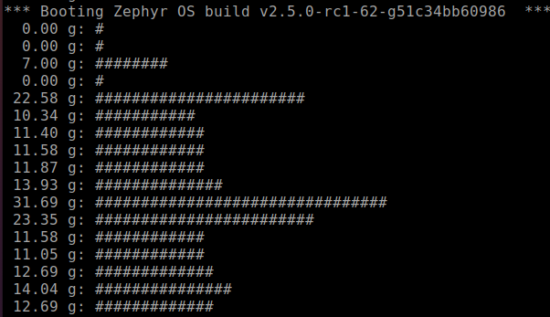

If you want to change to ADXL372_MEASUREMENT_MODE,

7) Go to /zephyrproject/zephyr/drivers/sensor/adxl372/

8) Edit Kconfig: Line 30 to

choice

prompt "Operating mode"

default ADXL372_MEASUREMENT_MODE

1. Rebuild and Flash again.

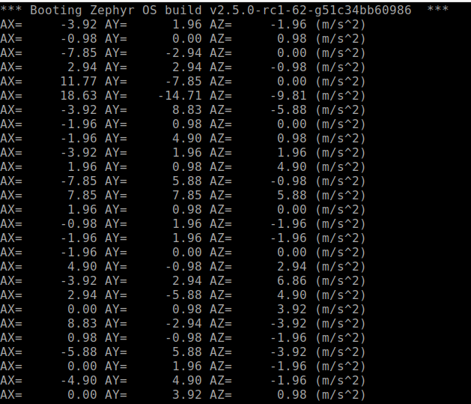

Sensor.h

zephyrproject/zephyr/include/sensor.h

